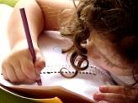  Literacy  In literacy we will practise our handwriting and make sure that we get the size and shape of the letters correct. We will practise writing sentences using capital letters and full stops. We will look at the story – The Three Little Pigs’ in talk for writing | 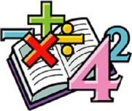  Maths  In maths we will be focusing on Place Value within 10. We will be sorting, counting and representing groups of objects. We will count on from any given number and count backwards within 10. We will look at 1 less, fewer, more and the same Less than, greater than and equal to. | 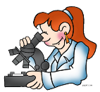  Science  We will work as scientists to learn about materials and their properties. We will identify a variety of materials, describe their simple properties and compare and group them. | 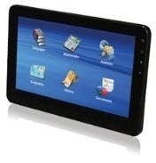  Computing  In computing we will be learning how to stay safe on the internet, log into a computer and how to access a website. We will use mouse skills to draw and manipulate shapes and understand how to layer shapes to create an image.
Humanities  In History we will be looking at the life of Florence Nightingale. We will be able to tell the difference between the past an now using pictures to find out about the past. | Year 1  Overdale Community Primary School  Autumn term 2023  Big Question: Why is Florence Nightingale still remembered today? |  | 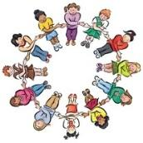  PSHE In PSHE we will be thinking about families and relationships. We will explore how families are different to each other. We will also explore how friendship problems can be overcome and explore friendly behaviours.
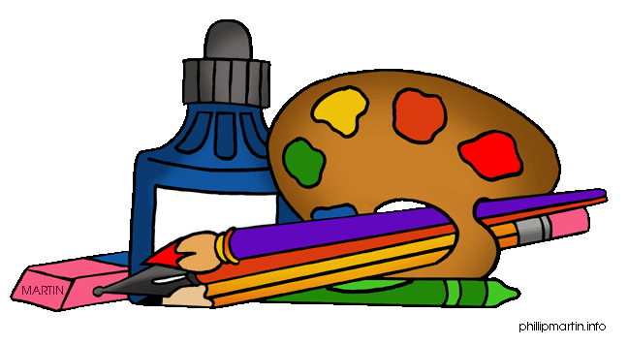  Art and DT  As artists we will use drawing and painting to develop a wide range of techniques whilst looking at the artist Louis Wain.  In DT we will be designing, making and tasting smoothies.  . | 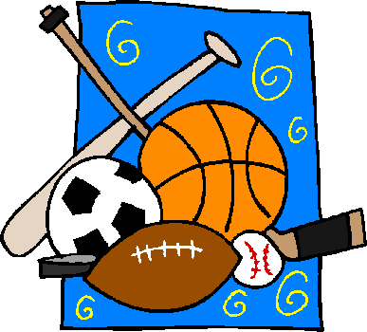  PE  In PE we will perform simple dances. We will master the basic movements of running, jumping, throwing and catching whilst playing simple net and wall games. | Music In music we will be focusing on pitch and tempo. We will play a range of tuned and un-tuned instruments using graphic notation. | RE In RE we will think about how we should care for others and the world and why it matters.
Reading: Children will be expected to read their home reading books three times a week with a written comment from a parent in their reading record. They will need a
school book bag and reading record. Book bags are available from the school office.
Maths: We will be focusing on numbers to 10 and counting groups of objects to 10 – any help at home with this would be great – thank you
Spelling: We will be learning to read and write the ‘tricky words’ and words using the phonemes we have been learning - a list will be sent home
weekly to practise

